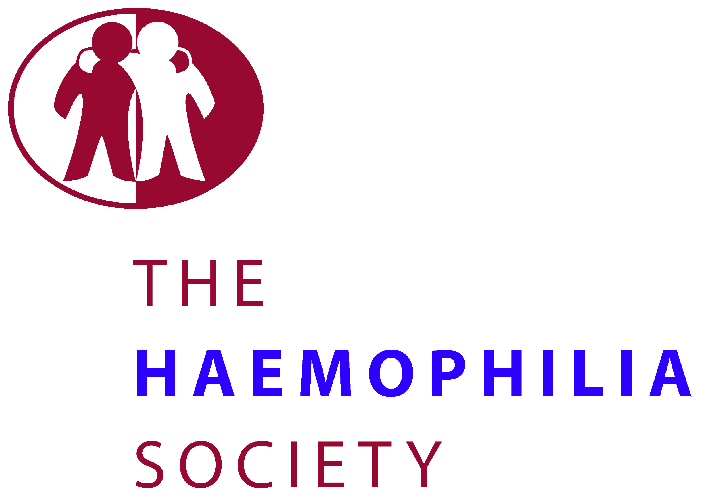
Willcox House
140 – 148 Borough High Street London. SE1 1LB
Freephone: 0800 018 6068
Admin: 020 7939 0780
Email: info@haemophilia.org.uk
Website: www.haemophilia.org.uk

04 February, 2016

Dear Member,

We are writing to you regarding the Department of Health’s Infected blood: reform of financial and other support consultation.

As you will probably be aware, the Public Health Minister, Jane Ellison MP, announced the launch of a consultation on reforms to the infected blood scheme in England, on the 21 January 2016.

Despite the announcement of an additional £125 million of funding, The Haemophilia Society has some serious concerns about the proposals, some of which we recognise are shared by our members. Our key concern is that the proposal to remove most discretionary payments will mean that the majority of people currently receiving financial support will actually be worse off under the new scheme. We are therefore calling on the Government to withdraw the consultation until the full impact of these proposals on individuals can be understood.

It is important that the Government and the Department of Health are made aware of these concerns and that we put pressure on them to reconsider these proposals. To help our members communicate their concerns to ministers, we have developed a campaign pack, which includes:

- Suggested text for you to use to respond to the consultation
- Suggested text for you to use to contact your local Member of Parliament (MP)
- Information for how you can contribute to an online petition on this issue

Additionally, you can go and visit your MP in person by attending a constituency surgery. To find out when your next one is, it is best to contact your MP’s office directly. You can find your local MP and their contact details through the parliament.uk website here: http://www.parliament.uk/mps-lords-and-offices/mps/

By supporting our members to understand the implications of these proposals, and how they can engage with the consultation, we hope to be able to ensure these concerns are heard and acted upon. However, please feel free to tailor any of these materials to suit you. We would also encourage you to share your own views on the consultation, and to include how the proposals will affect you personally. If you choose to use this material when writing to MPs etc, please ensure that it is clear that these are your own views rather than just The Haemophilia Society’s. Also, please note that this consultation is only applicable to people in England.

If we are not successful in getting the consultation withdrawn, we will produce further information on how to complete the questionnaire to have the most impact and ensure the government have a very clear view of why this proposal is not acceptable.

Please do not hesitate to contact us if you require any further information on the consultation, or how you can respond.

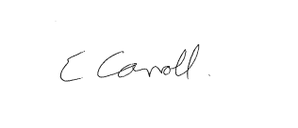
Yours sincerely,

Liz Carroll
Chief Executive

